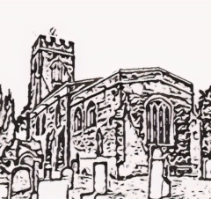**Middleton Parish Council**

Notice of Middleton Parish Council Meeting

Wednesday 23rd July 2025-Middleton Village Hall, 7.00-8.30pm

Any members of the public or press may attend. Public questions will be taken at the start of the meeting by prior notice to the Clerk. Electors will not be permitted to join in any debate on matters that are to be considered after the meeting starts

**AGENDA**

1. Private and confidential matter

*– in view of the confidential nature of the business about to be transacted, it is advisable in the public interest, as if members of the public were present during the consideration of such business, there would be disclosure to them of exempt information under paras 1 and 11 of Part 1 of Schedule 12A of the Local Government Act 1972, that the public be temporarily excluded and they are instructed to withdraw if present at the start of the meeting.*

2. Public questions –

3. Community Update:

4. Apologies for absence

5. Declarations of personal and prejudice interests

6. Minutes of the previous meeting

7. Matters arising

8. Reports from Councillors and Clerk

9. Planning applications

10. Finance

11. AOB